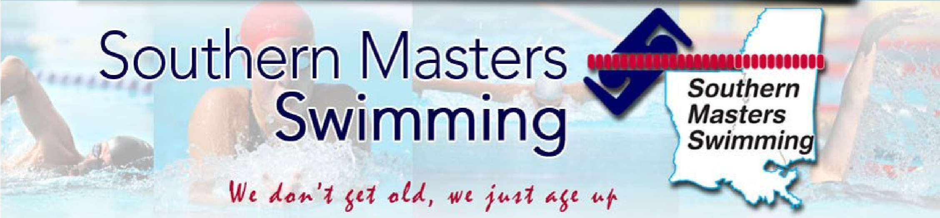

Page 1 of 4

SMS Officers
Aaron Schneider General Chair
Nan Fontenot
Vice Chair
Barry Edwards Treasurer
Steve Kernion Secretary
Rick Hartman Registrar
Liz Cumming
Sanction Chair
Alyssa Berry
Coaches Chair
Open
O.W./Adult Swim
Doug Holmes
Lane Lines Editor
Kevin Ayer Website/Records
Mike Freyder
Social Media
Kelly Denning
Top Ten Chair
Amanda Janszen
Officials Chair

Lane Line June 2022 southernmastersswimming.com

2022 promises to be a big year in USMS and SMS as swimmers get back in a routine of practicing, team workouts, and competition. It is wonderful to be able to
socialize, practice, party and travel with less fear of Covid after all the meet
cancelations in 2020 and 2021. Hopefully you are swimming laps and training
for the next meet in our area which is the SMS LCM Championship on August
14 & 15 in Shreveport. See the following article and invitation for more details. Our Registrar Rick Hartman will be sending email notifications to SMS members and you
will be able to find Entry Forms at USMS.org and Southernmastersswimming.com.

Hopefully you were able to participate in some of the USMS sanctioned meets
This winter and spring including One Hour Virtual e-Postal, SE Zone Meet at Auburn
Alabama, Deluna’s O. W. Swim in Pensacola, USMS Spring National Championships
for SCY in San Antonio, Texas, National Senior Games for SCY in Ft. Lauderdale
Florida, and you plan to compete in the 5k & 10k e-Postal in a 50m pool between May 15–Sept 15, 2022. Regrettably, our SMS SCY Championship Meet had to be cancelled due to lack of entries. Our apologies to Charlie Hoolihan and Don Carroun
the meet directors who have been willing to step up and host SMS Championship
meets and the eleven annual Pelican Athletic Club one day meets usually held on
the last Sunday of September.

The Annual SMS Membership Meeting could not be held since the SCY
Championship meet at PAC in Mandeville was cancelled. The SMS Board will hold
the 2022 Annual Membership meeting in Shreveport on Sunday August 15th during lunch following the conclusion of the LCM Championships. The SMS board will recognize the Outstanding SMS Male Swimmer and the Outstanding SMS Female Swimmer for 2021 based on the number of points scored by placing in the USMS
Top Ten for the past year. All SMS members who swam a Top Ten time(s) in the previous year in any of the three courses (SCY, SCM, & LCM) will receive an appropriate award and recognition. 2021 was a banner year for 36 SMS swimmers
who placed in the Top Ten in their age group in the nation in USMS sanctioned
meets in individual events or relays. Also 26 SMS records were set.

Red River Masters to host the SMS LCM Master’s Championship meet in Shreveport August 13 & 14, 2022

The cost is an unbelievably low $30 for the two-day meet. All the individual events including the 1500 m free and two relays will be offered and times will qualify for Top Ten and SMS records. A light lunch will be available on both Saturday and Sunday after your events. SMS members will receive an invitation via email from our Registrar Rick Hartman. Entry forms will be posted on southernmastersswimming.com and USMS.org.

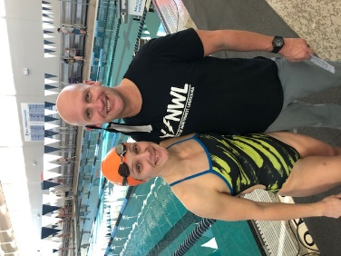
We are indebted to the Meet Directors, John and Amanda Janszen (pictured) and the who have stepped up to host the SMS LCM Championship Meet along with Red River Masters.

The meet warmups will be at 1 PM to allow those SMS members farther away to drive here on Saturday August 13th morning. We will hope for and need early entries so we can be assured of enough swimmers so the meet will not have to be cancelled. This meet will allow SMS swimmers to compete in a long course meet that is located much closer to home than the USMS Summer Nationals in Richmond Va. Meet will be held in the BHP Billiton NW YMCA in a fast and nine foot deep 50m pool. Note that entries, check, and copy of USMS card must mailed and received by John Janszen by August 6. Four events per day plus relay.
Events: Saturday August 13, 2022 Warm-up 1:00 p.m. Meet Starts 2:00 p.m. 800 Free 50 Fly 100 Breast 200 Back 100 Free 200 Fly 50 Back 200 IM 400 Free 200 Free Relay
Sunday August 14, 2022 Warm-up 8:00 a.m. Meet Starts 9:00 a.m. 1500 Free 100 Fly 200 Free 50 Breast 100 Back 50 Free 200 Breast 400 IM 200 Medley Relay.

Those from southern part of Louisiana and Mississippi may want to register at the following hotels close to the pool. A social on Saturday evening is being considered, and we all know how the Riptide love to party.
Home2Suites Hampton Inn Boomtown Casino
6650 Eastbank Drive 8340 Millicent Way 300 Riverside Dr
Shreveport, LA 71105 Shreveport, LA 71115 Bossier City, LA 71111
2022 SMS Swim Schedule

One Hour Virtual e-Postal 25yd pool January 1-31, 2022

SE Zone at Auburn Ala 25yd pool March 19-20, 2022

SMS SCY Championship PAC in Mandeville Cancelled May 5-6, 2022

Deluna’s O. W. Swim Pensacola Fla April 22-23, 2022

5k & 10k e-Postal 50m pool May 15–Sept 15, 2022

USMS Spring Nationals SCY San Antonio Tx April 28-May 1, 2022

National Senior Games SCY Ft. Lauderdale Fl. May 13-15, 2022

La. Senior Games LSOG LSOG in N.O. No swimming events this year

USMS Summer Nationals LCM Richmond Va. Aug 3-7, 2022

SMS LCM Championship Shreveport, 50m pool August 14 & 15, 2022

FINA World Master’s Championship postponed to 2023

Swim Across the Bay Bay St. Louis TBA Sept. 2022

Pelican Athletic Club SCY Mandeville Saturday Sept. 24, 2022

3000 & 6000yard e-Postal any 25 yd pool Sept 15- Nov 15,2022

Huntsman World Senior Games St. George Utah October 2022 National Senior

SMS SCM Championships 25m pool TBD TBA December, 2022

