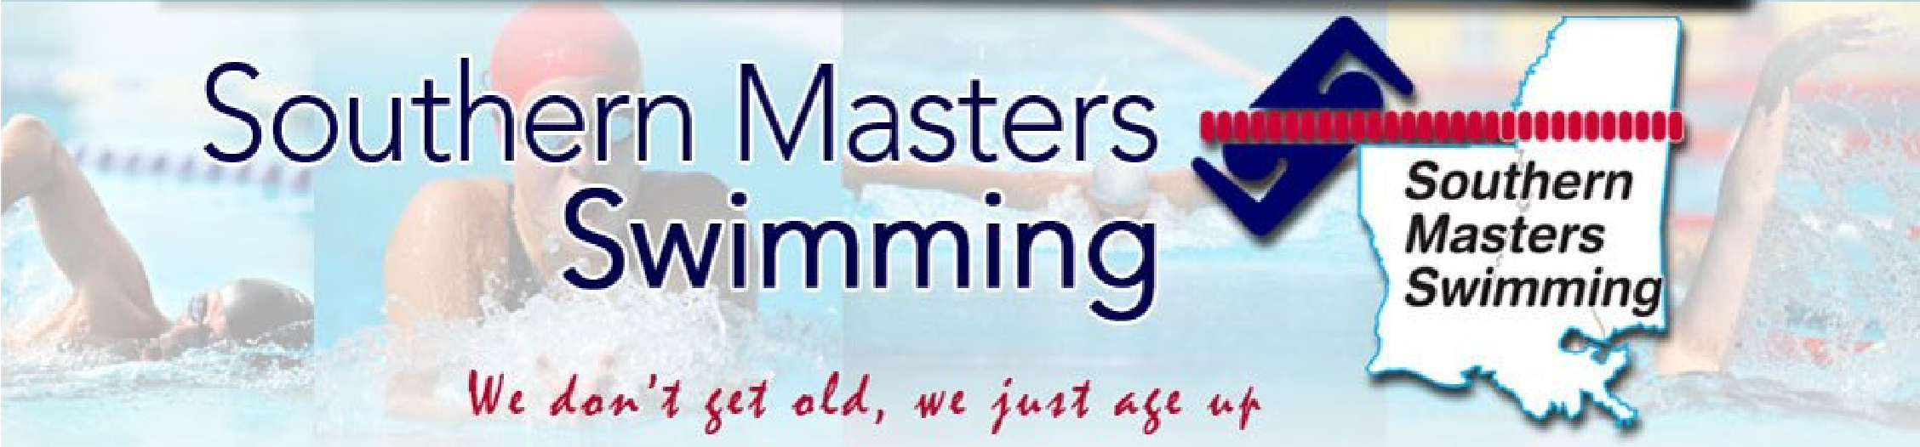

Page 1 of 6

SMS Officers
Aaron Schneider General Chair
Nan Fontenot
Vice Chair
Barry Edwards Treasurer
Steve Kernion Secretary
Rick Hartman Registrar
Liz Cumming
Sanction Chair
Alyssa Berry
Coaches Chair
Open
O.W./Adult Swim
Doug Holmes
Lane Lines Editor
Kevin Ayer Website/Records
Mike Freyder
Social Media
Kelly Denning
Top Ten Chair
Amanda Janszen
Officials Chair

Lane Lines February 2022 southernmastersswimming.com

Time to renew for 2022

Yes, you want and need to be a member of USMS and Southern
Masters Swimming (SMS). There are lots of events planned for 2022
since many were cancelled or postponed over the past two years.
Most upcoming meets are only a short driving distance away.

See “2022 Swim Schedule” below and many more listed on USMS
.org. SMS is planning three Championship meets in Louisiana, PAC
agreed to host the SMS SCY Championship May 6-7, 2022, the
popular Auburn-SCY meet is coming up March 19-20, and the National
Senior Games swimming events will be held May 13-15 in Fort
Lauderdale.

The USMS Virtual One Hour swim was held January 1-31,2022.
This National competition, previously called the One Hour E-Postal
event was swum by eight SMS swimmers in local 25-yard pools. Amanda Subenko, age 28, 8th place, Alyssa Berry, age 34, 15th place, Elizabeth Cumming, age 42, 31st place, Sarah Gillen, age 47, 11th place, Catherine Giarrusso, age 45, 24th place, Aaron Schneider, age 52, 8th place. Barry edwards, age 58, 17th place, and Doug Holmes, age 85, 2nd place.

Set some goals, join the USMS/SMS, and plan to compete in 2022.

The SMS Board voted to recognize the Outstanding SMS Male Swimmer
and the Outstanding SMS Female Swimmer based on the number of
points scored by placing in the USMS Top Ten for the past year. All SMS members who swam a Top Ten time(s) in the previous year in any of the three courses (SCY, SCM, & LCM) will receive an appropriate award and recognition. 2021 was a banner year for 36 SMS swimmers who placed
in the Top Ten in their age group in the nation in USMS sanctioned
meets in individual events or relays. Also 26 SMS records were set by
SMS swimmers in master’s meets. This recognition is acknowledged
and the names are listed in the Awards and Top Ten section of Southernmastersswimming.com.

Southern Masters Facebook has over 100 members and is a great way to keep up to date on swim events and activities in Louisiana, Mississippi, and the United States. Mike Freyder is the new chair for Social-Media, and has SMS Facebook page up and running after the unfortunate and sudden death of long-time Facebook Editor Ann Walton. The Facebook group’s main purpose is to build community among SMS swimmers and to support their pursuit of health and fitness. We sharing region and club info plus tips and updates relevant to swimmers. If you are an SMS member and want to join, go to facebook.com/groups/southernmastersswimming. Welcome.

Crawfish Masters Breakfast Challenge Meet
Nan Fontenot and the Crawfish Masters held the First Annual SCY Breakfast Challenge on December 4th in place of the third Southern Masters Swimming (SMS) Championship. SMS was able to hold two of their three annual Championship meets in 2021 being 1) the SCY Championship for SMS held the first weekend in May at the Pelican
Athletic Club in Mandeville, and 2) the SCM Championship for SMS held July 31-August 1 at the Crawfish Masters Ketcham Pool in Baton Rouge. There was no LCM pool set up for 50 meters available for LCM in Louisiana in 2021, so Nan, knowing competitive swimmers needed an event, substituted her Breakfast Challenge below:

Photos from the Breakfast Challenge:
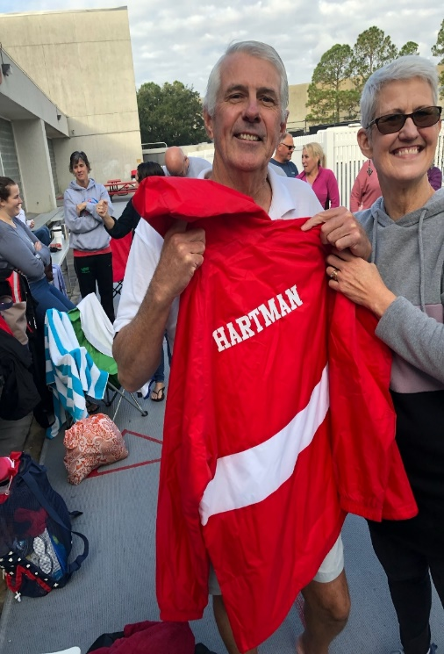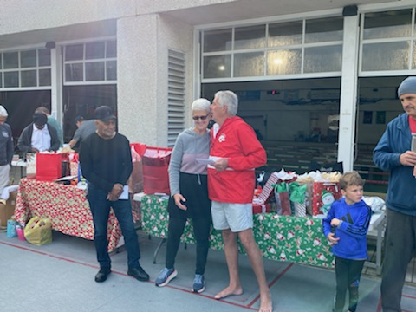
Nan’s Report: What an INCREDIBLE time and great competition, we had Saturday December 4, 2021, as well as fellowship! We had 39 participants in the meet and MANY helping time and run the meet. Special THANK YOU to Terry Jaynes, Joe Lee, and Randy Fontenot for the fantastic pancakes and omelets.
Thank you to everyone who contributed toward food for the event - it was PERFECT!

Thank you so much for my gift - my greatest gift is each of you as you continue to
show up and swim, but more importantly, I witness you being a family giving HOPE - Helping One Person Everyday - and especially within our Crawfish family. We indeed are greatly blessed. We were blessed to have RIPTIDE swim team join us - they (10 swimmers) came all the way from New Orleans to join us!

So proud of Rick Hartman and George Newport who we honored them today.

Meet SMS Registrar Rick Hartman
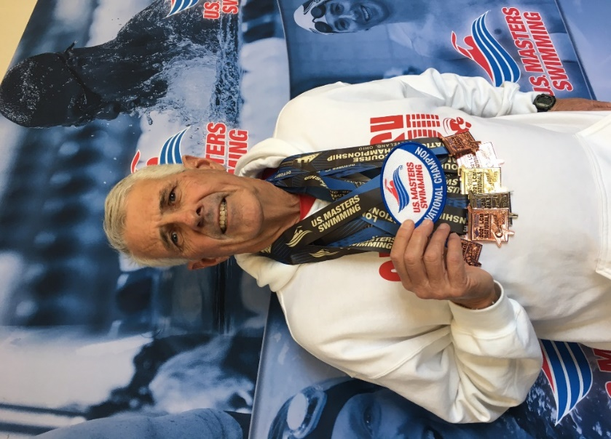

Rick swims with Southern Masters Swimmers and works out with Nan Fontenot (coach) at the Crawfish Aquatics facility in Baton Rouge. Rick is also the Southern Masters Swimming Registrar. In that position, Rick has the responsibility for checking eligibility/membership with USMS and moving swimmers between teams, if requested by the swimmer. Rick also has the responsibility for sending emails to membership informing them of important goings-on in both USMS and the Southern LMSC (Local Masters Swimming Committee).
Rick swam off and on growing up in central Florida, and attended Auburn University in the mid-70s on a swimming scholarship. After Auburn, Rick taught high school and coached swimming in Florida. He then attended LSU, served as an assistant swim coach, and earned his Master’s degree in Marine Biology. After graduation, Rick served as head swimming coach for Bengal Tiger Aquatic Club and LSU Aquatics until the early 1990s. Then Rick dropped out of swimming completely.
Rick got back into swimming in 2014 to help lose weight and improve his overall health at the recommendation of his doctor. Since then, Rick has broken virtually all of the freestyle records in the 60-64 age group in all pool lengths, and some of the records in the other strokes as well. He is now working on breaking records in the 65-69 age group. He has also been ranked as high as 4th in the world. Rick is most proud of recently winning the 400-meter freestyle at long course nationals in Cleveland. Rick’s best events are middle distance, even though he was a sprint freestyler in college. Rick says what he enjoys most about swimming at Crawfish is the comradery and social aspects of the team and indicated that without that support system and fun during practice, he would have dropped out of the sport a long time ago. He says competing in meets helps keep him honest in training and that he enjoys pushing himself to see what he can do. Rick ways one of his goals at Crawfish and Southern Masters overall is to increase participation in competitions.

Pelican Athletic Club to host the SMS SCY Master’s Championship swim meet in Mandeville 5/5-6/2022

All the individual events including the 1650 yard free will be offered and times will qualify for Top Ten and SMS records. SMS members will receive an invitation via email from our Registrar Rick Hartman. Entry forms will be posted on southernmastersswimming.com and USMS.org.

We are indebted again to the Meet Directors, Charlie Hoolihan and Don Carroum (pictured) who ran a great SCY Championship Masters swim
and meet in May 2021 with 80 swimmers.
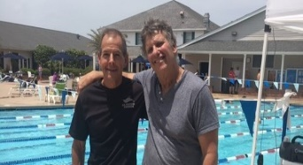
The meet warmups will be later to allow those SMS members farther away to drive here on Saturday morning. We will hope for the good turnouts we had for the SCY and SCM Championships last year. This meet will allow SMS swimmers to train a week before the National Senior Games in Fort Lauderdale Florida. However, the PAC meet is primarily designed as a lowkey swim meet locally for SMS members who want to compete for the first time or fiftieth time.
2022 SMS Swim Schedule

One Hour Virtual e-Postal 25yd pool January 1-31, 2022

SE Zone at Auburn Ala 25yd pool March 19-20, 2022

SMS SCY Championship PAC in Mandeville May 5-6, 2022

Deluna’s O. W. Swim Pensacola Fla April 22-23, 2022

5k & 10k e-Postal 50m pool May 15–Sept 15, 2022

USMS Spring Nationals 25yd pool April 28-May 1, 2022

National Senior Games SCY Ft. Lauderdale Fl. May 13-15, 2022

La. Senior Games (LSOG) LSOG in N.O. No swimming events this year

USMS Summer Nationals LCM Richmond Va. Aug 3-7, 2022

SMS Shreveport LCM meet 50m pool TBD TBA August, 2022

Swim Across the Bay Bay St. Louis TBA Sept. 2022

Pelican Athletic Club SCY Mandeville Saturday Sept. 24, 2022

3000 & 6000yard e-Postal any 25 yd pool Sept 15- Nov 15,2022

Huntsman World Senior Games St. George Utah October 2022 National Senior

SMS SCM Championships 25m pool TBD TBA December, 2022

Five Backstroke Drills
Cokie Lepinski, 2014 USMS Coach of the year, prepared this five-drill sequence to put all the elements together in your backstroke. There’s a big emphasis on kicking as it’s fundamental to good backstroke. Your kick helps drive the rotation of your body and aids in the power you can achieve out of each pull.

Flutter Kick Cross
Kicking is essential to an efficient backstroke. This drill changes your balance point and causes you to work a little harder at finding your horizontal line. Kick on your back with palms resting on opposite shoulders. Find your horizonal line with a neutral head position where just your face is clear from water. Minimize or eliminate any big arch in your low back to allow your hips and feet to remain near the surface. Focus on “shaking” your thighs vigorously to generate your kick and think about turning your feet slightly inward (pigeon-toe).

Quarter-Arm Lifts
This drill aids in finding the proper timing of the arm lift in the recovery and requires that all-important steady kick. Start by kicking on your back while resting your hands on your thighs and rotating hip to hip as you kick. Drive your rotation from where your hands rest on your thighs. Connect your shoulder, hips, and heels in your rotation and hold the rotation to about 30–45 degrees. Each time you rotate, lift your upper arm about a quarter lift, roughly 10–15 inches off your hip, and then return it to rest on your thigh. Rotate from hip to hip and avoid stopping in the position where you’d be flat on your back. Time your arm lift with the rotation of your shoulders, hips, and heels.

Arm-Lead Balance with Rotation
Kick on your back, slightly balancing on one hip at about 45 degrees, with your lower arm extended in the water over your head as if you just entered your hand to start the underwater pull. The other arm rests on your thigh. Kick and count to 10, then execute a single stroke to rotate to the other side. Work to find your balance quickly and aim to hold a good horizontal line. Continue the length in that fashion and keep your kick going strong. This drill teaches you to have a long body line, working the rotation all the way down your body and not just using your arms or upper body. Stay long and taut.

L and Switching L Drill
Work from the same starting position of the Arm-Lead Balance drill above with one small change. Instead of resting the one arm on your thigh, it now points straight up to the sky. You should be able to visualize an “L” in your silhouette, with the one arm back and one arm up. At first, just try kicking in this position, remembering to balance slightly on the opposite hip of the arm reaching to the sky. Once you’ve established good balance in this position, move to the Switching L Drill, where you count to 10 and switch sides with a single stroke and rotation. Like Flutter Kick Cross, this drill changes your balance point, and you have to work harder to return to a good horizontal line with each arm switch. This requires you, once again, to work those legs steadily. You can do multiple lengths of this and begin to reduce the count from 10 to 8, 6, 4, and 2.

3-6-3 Backstroke
Swim three strokes of backstroke and end in the Arm-Lead Balance position, remembering to balance slightly onto one hip. Continue kicking, count to 10 and do three more strokes, again ending up in the Arm-Lead Balance position. Continue the length in this fashion. Just like all the drills above, you need to keep that kick steady without a pause. This drill reinforces that backstroke is swum hip-to-hip and not flat on your back.
This sequence of backstroke drills is a great way to reset your backstroke. Take the time to work through the drills. Don’t race through them, but really think about what you are doing and why. Awareness is critical for your stroke development. Keep at it and you’ll soon establish a smooth, rhythmical backstroke.

